**THIS IS THE TEMPLATE-TITLE FOR ISon 2022 PAPERS**

| *Tina Template* | *Francois Format* |
| --- | --- |
| Formular Group | Second Institute |
| Documenttown, Paperbourg | Address |
| template@formular.com | your.email@add.ress |

**ABSTRACT**

We generated this LaTeX template by a mild adaptation of the

ICAD proceedings template. The template is also highly similar to AES16th, WASPAA’97, WASPAA’99 and ICASSP’99 templates and aims at producing conference proceedings in electronic form. The format is essentially the one used for ICASSP conferences.

Please use either LaTex or the Word format to prepare the submission. Submit your paper in pdf format.

For LaTeX we recommend using our Overleaf template (https://www.overleaf.com/latex/templates/our-current-ison-template/ybnrhcrxsgrc).

# **INTRODUCTION**

This is the template for the ISon 2022. This is the template for the ISon 2019. This is the template for the ISon 2016. This is the template for the ISon 2013. This is the template for the ISon 2010.

## **Figures**

Here an example for a figure.

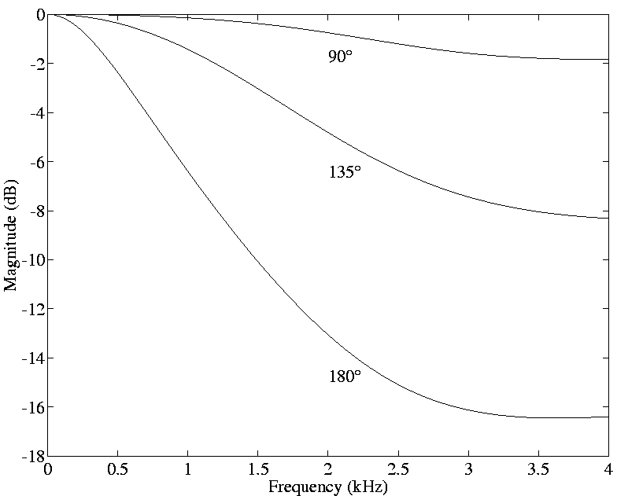

Figure 1. *The figure caption is 9 point Times New Roman and centred. There should be 15 points between the caption and the following text.*

## **Equations**

Equations should be placed on separate lines and numbered:

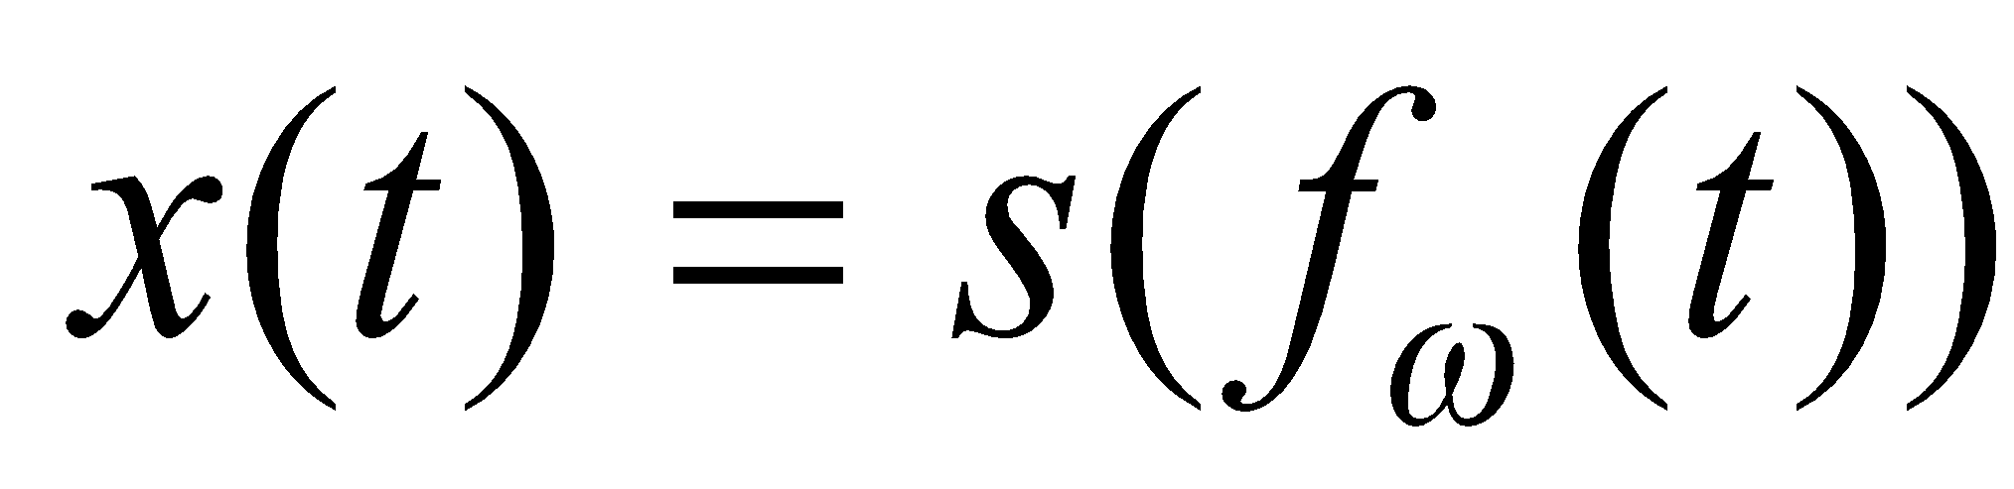 (1)

Where is a special warping function



(2)



A residue theorem states that

(3)



Applying theorem 3 to 1, it is quite straightforward to see that

(4)



## **Page Numbers**

Page numbers will be added to the document electronically, so please leave the numbering as is, that is, the first page will be ISon2022-1 and the last page will be, e.g. ISon2022-6.

# **CONCLUSIONS**

Write a conclusion…

# **REFERENCES**

1. A. Bee, C.D. Player, and X. Lastname, “A correct citation,” in *Proc. First Int. Conf. (IC)*, Helsinki, Finland, June 2001, pp. 1119–1134.
2. E. Zwicker and H. Fastl, *Psychoacoustics: Facts and Models*. Springer-Verlag, Heidelberg, Germany, 1990.